**MCIS 6333_002 – Data Visualization Programming**

**Fall 2023 Dr. Esther Ledelle Mead, Professor**

**Assignment 6 (A6)** Module 6 12 points

**Instructions**: Work as a team to fill in your team and team member information. Then continue to work as a team to enter responses for each of the three sections: 1) DVs programmed in Python, 2) DVs programmed in R, and 3) Data insights. Do not change the file name of this template except for adding your Team Number and name at the end of "A6-MCIS6333_002" (for example, "A6-MCIS6333_002-Team_1-Bad-To-The-Bone.docx"). Do not remove any content from this template. **Before submission, be sure that all required components are visible on the final version of your file by expanding their edges as needed and by inserting extra space as needed. Be careful not to move around the objects on this document in a way that messes up the flow. As you add content, the items will be pushed down, which is fine, but be sure to not let any DVs get split up or caught in between two pages. Create as many additional pages on this file as necessary. Turning in work created by students/teams from a past semester will result in a score of zero (0) and an official Academic Dishonesty and Integrity Violation report for each team member to the SAU Authorities.**

**Team #: 1____ Team Name: _Datavana__________________  
   
 Contributed effort to this A6? *(Y or N)***

**Team Members (*full names are required*): *Answer required for each team member):*  
1. Revanth Kumar Madasu____________________ Y____  
2. Anusha Pakkiru__________________________ Y____  
3. ________________________________________ _____  
*(Remove any unused lines from above.)***

**1) Data visualizations (DVs) programmed in Python that show the Parallel Coordinates plot, Radar Plots based on Ethnicity, Dietary Preferences**:

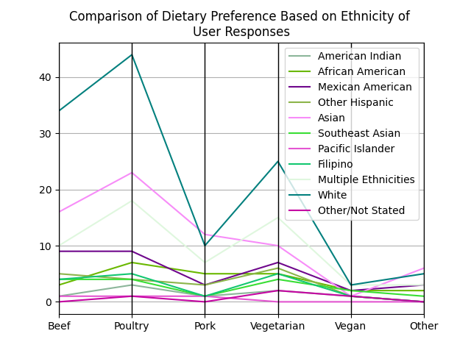

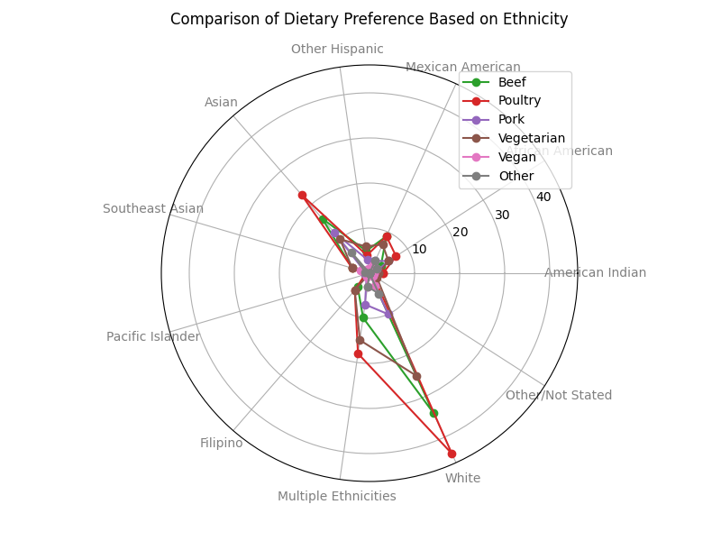

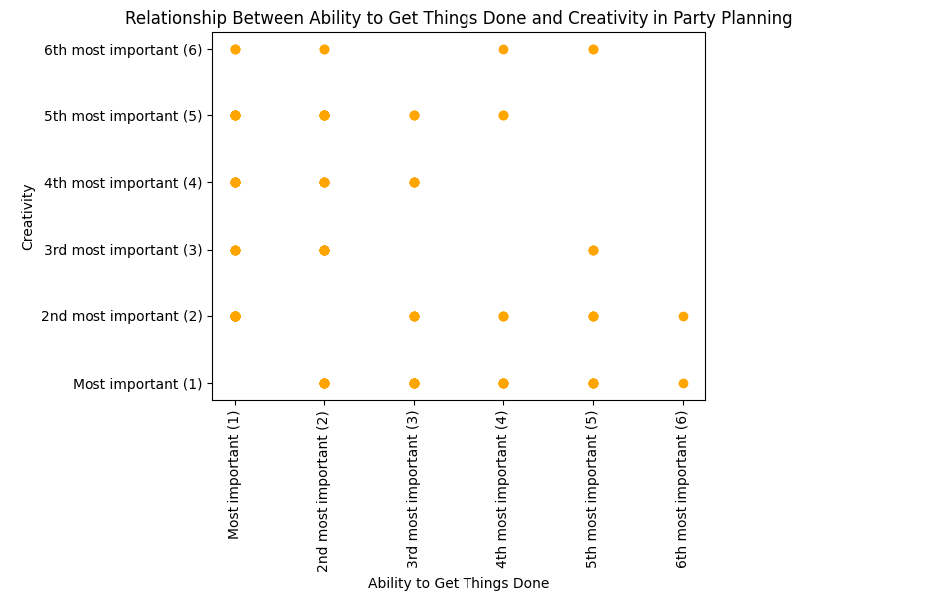

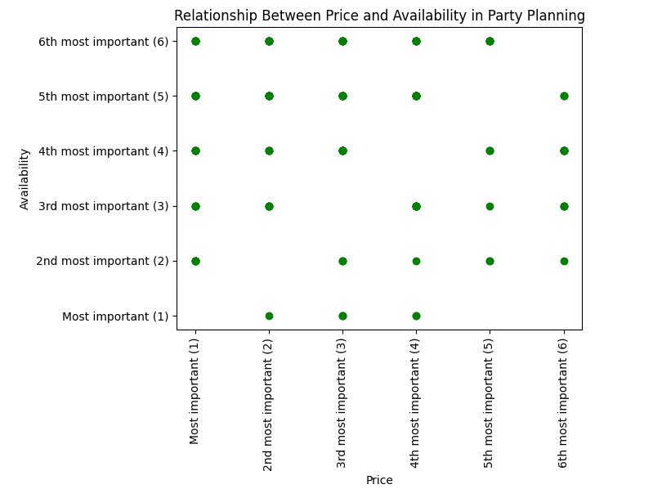

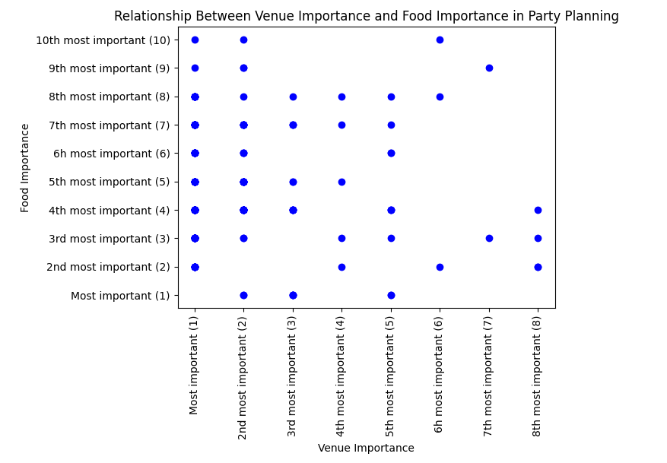

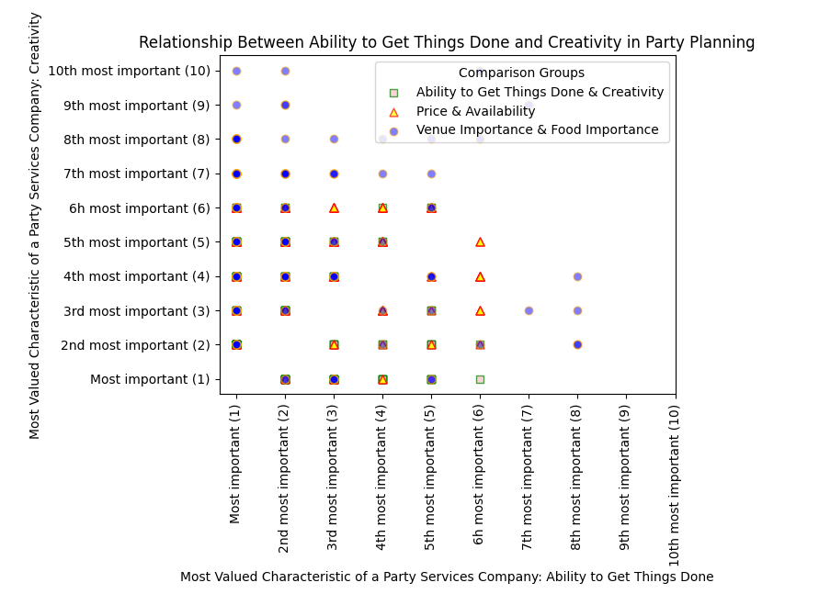

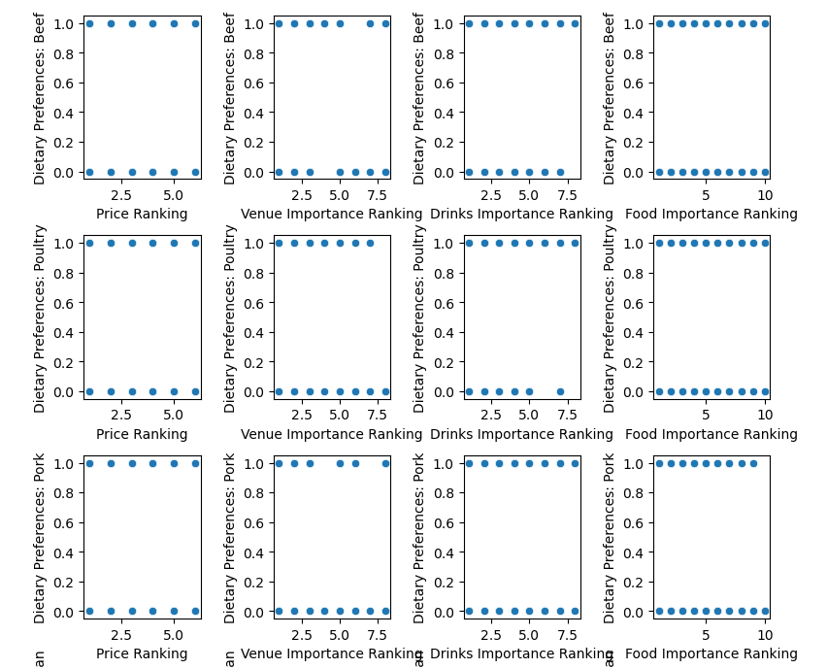

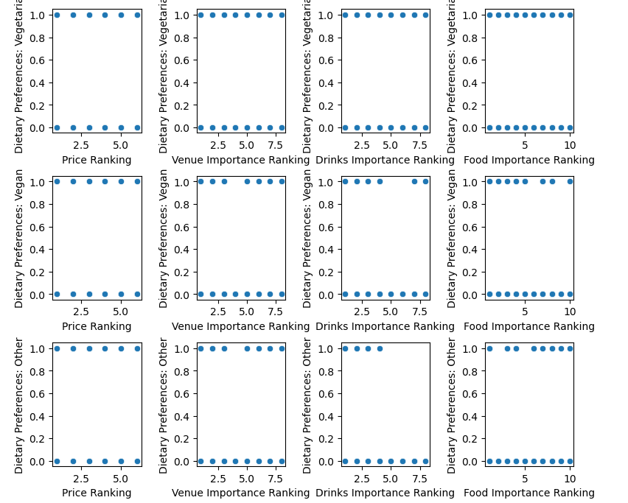

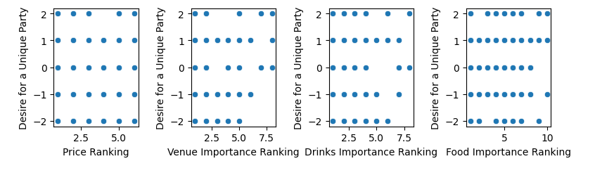

**2) Data visualizations (DVs) programmed in R that show the Parallel Coordinates plot based on Ethnicity, Dietary Preferences**:

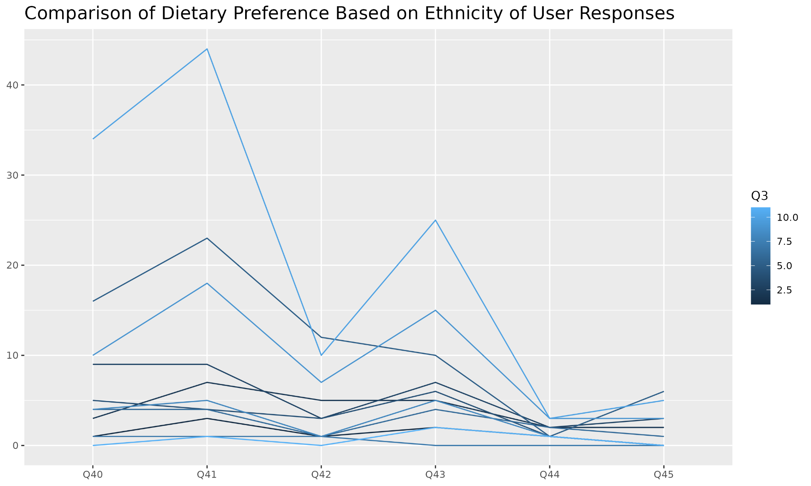

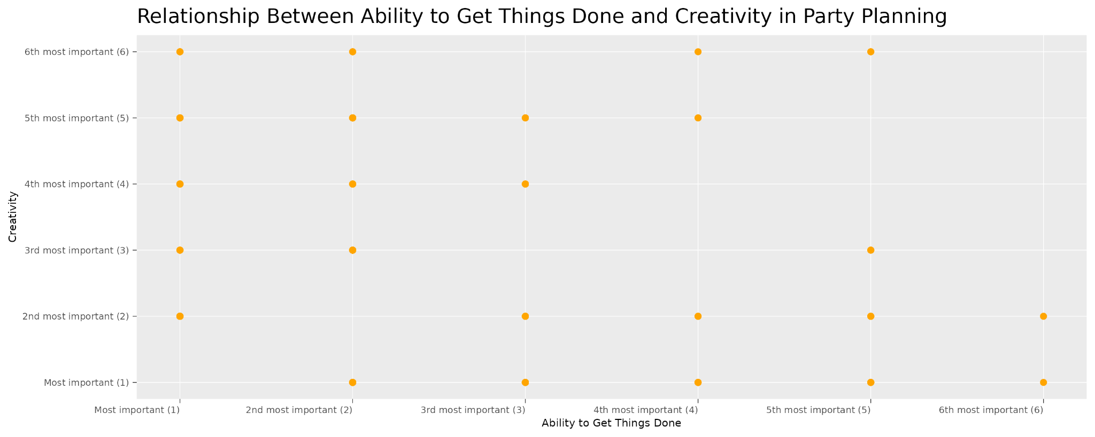

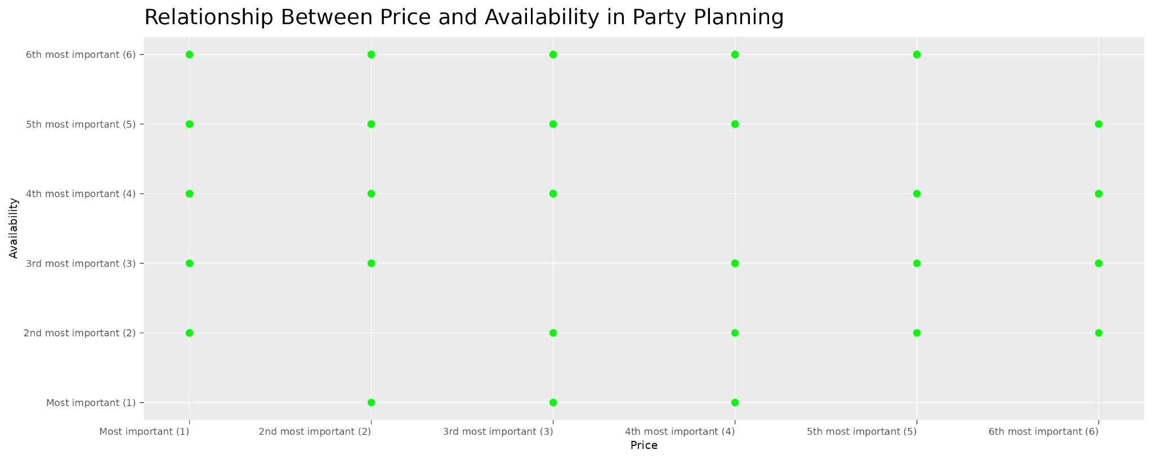

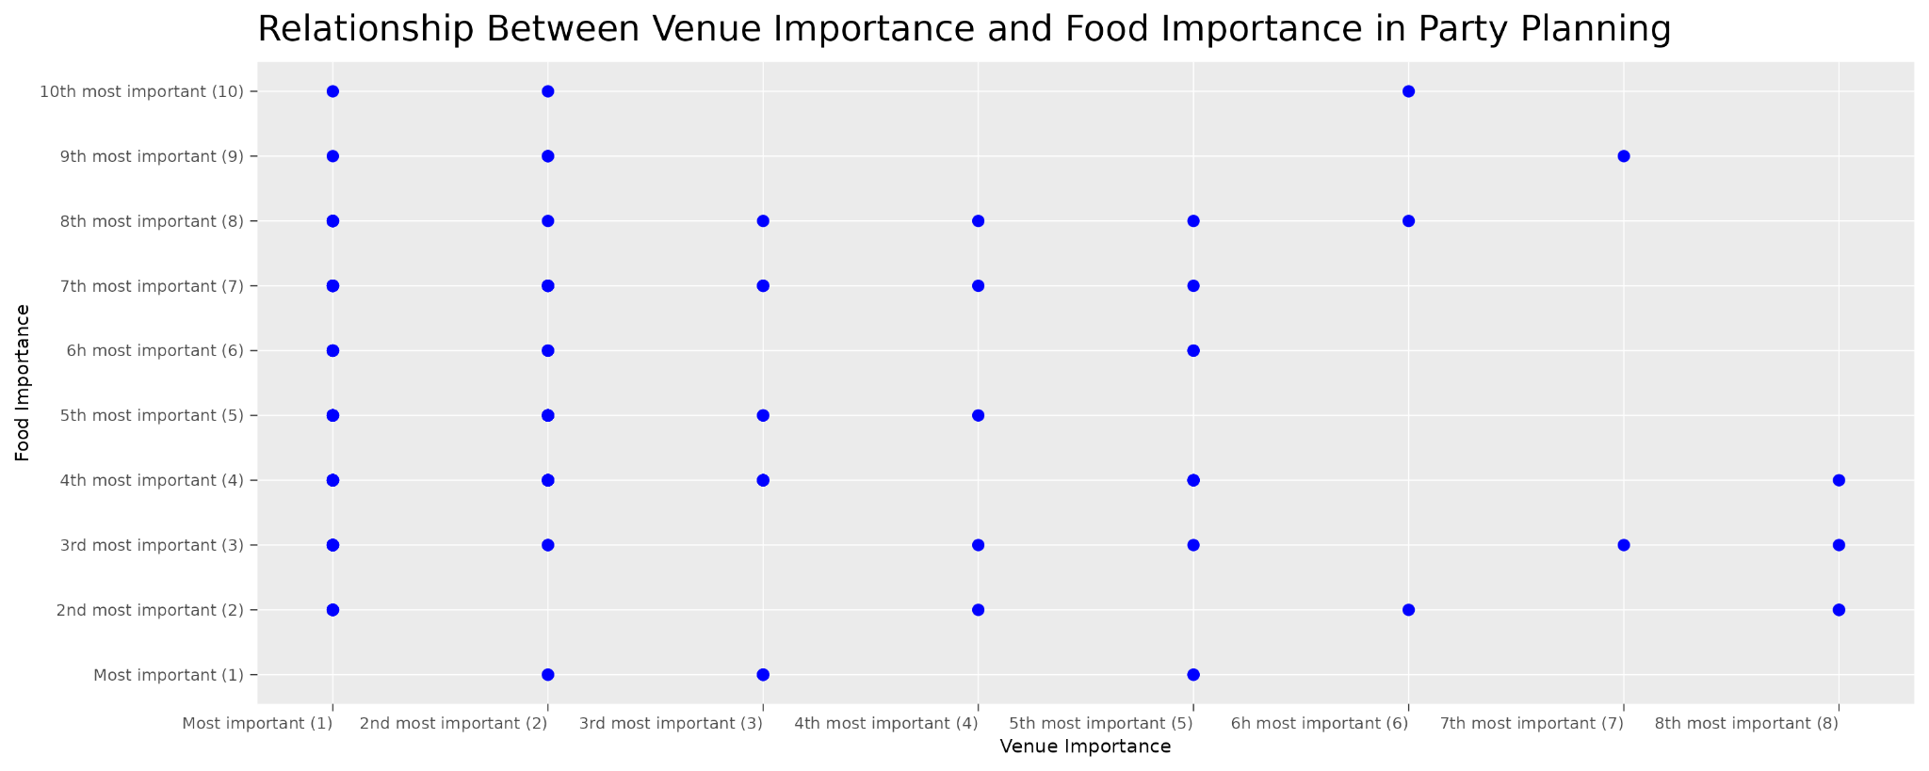

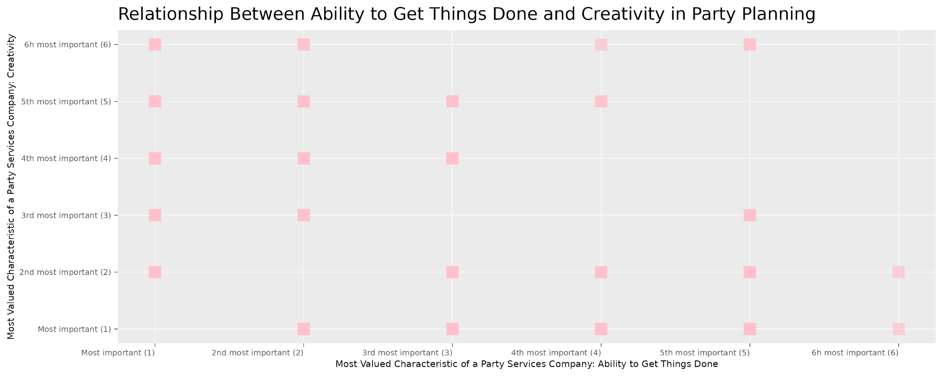

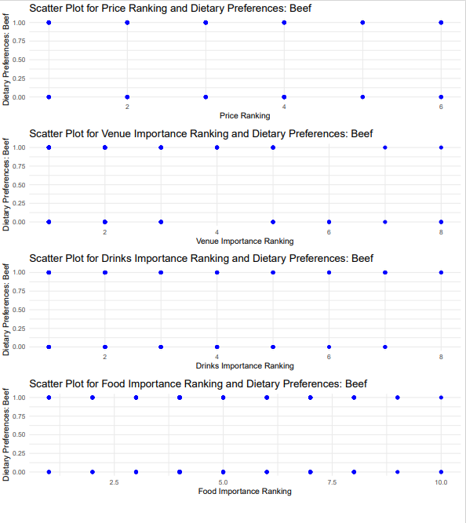

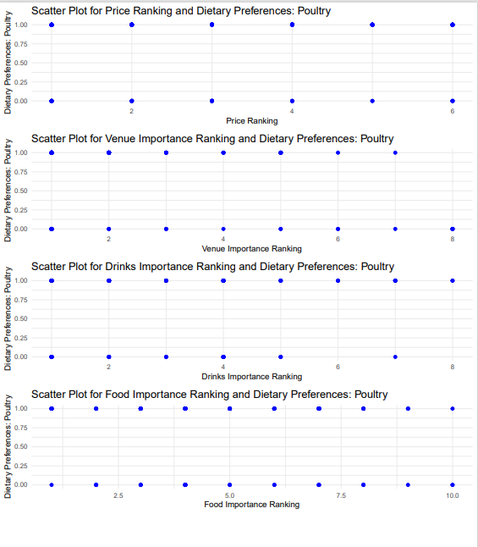

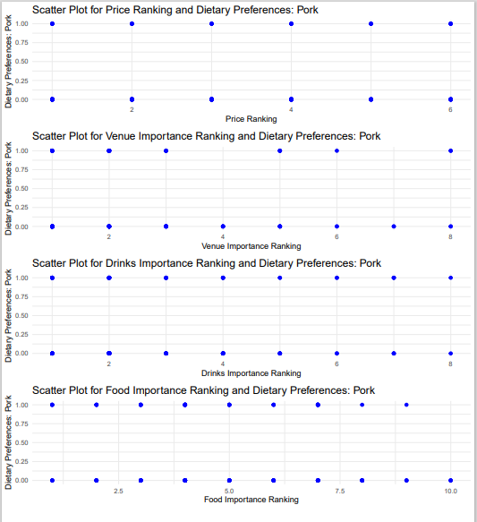

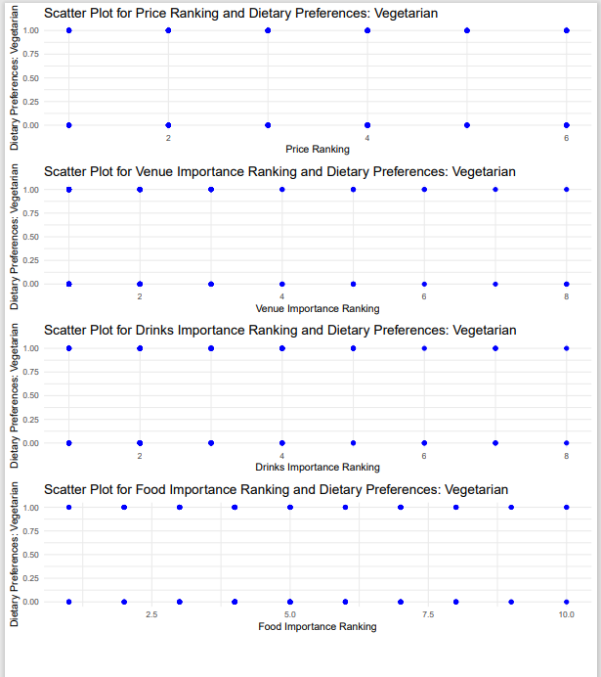

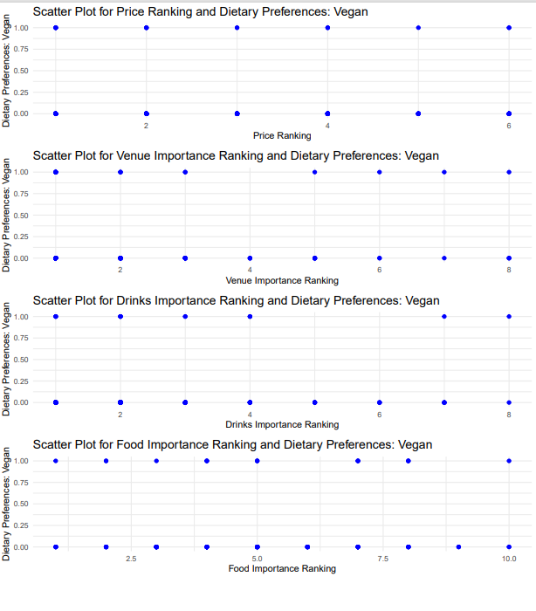

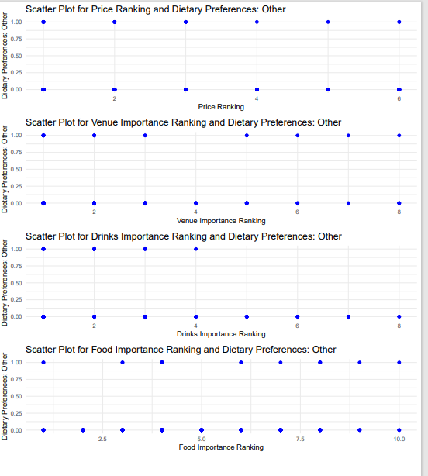

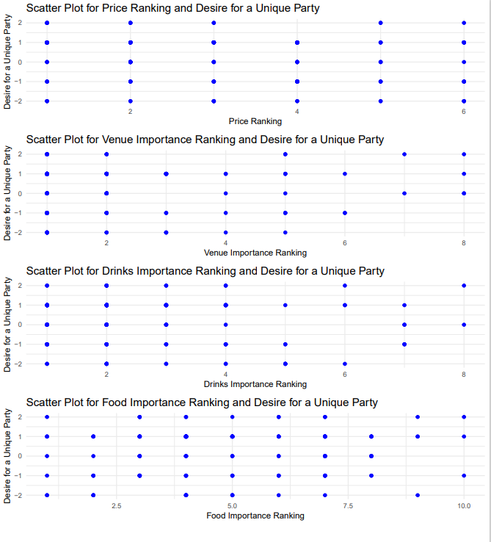

**3) Data insights:**

Below this text instruction line, insert at least three properly structured and arranged sentences **in written paragraph format** (grammar, spelling, sentence casing, use of spacing, symbols and punctuation) to compose some data insights that can be logically deduced from the DVs that you provided above and **that say something about the data with regard to the M6 theme of Relationships**. If you write more than three sentences, be sure to use appropriate paragraphing structure for technical writing[1]. Do not remove this instruction block content. Removing any content from this template results in a 1 point penalty.

**Dietary Preferences by Ethnicities:**

1. Poultry is most preferred among different ethnic groups. Groups reported as “White”, “Asian” and “Multiple ethnicities” have the highest poultry preference.
2. Most Preferred dietary choice after “Poultry” is “Vegetarian”. Groups reported as “White” and “Multiple Ethnicities” have highest vegetarian preference.
3. Groups reported as “Asian” have less proportion of Vegetarian and Vegan preferences compared to other groups.

**Insights from Party Planning Scatter Plots**

The scatter plots in your code show that party planners have diverse preferences. There's no strong trade-off between attributes like "Ability to Get Things Done" and "Creativity" or "Price" and "Availability." However, there's a positive correlation between "Venue Importance" and "Food Importance."

The scatter plots visually highlight these differences, emphasizing the need for flexibility in catering to various preferences in party planning.

The matrix of scatter plots also allows for the examination of relationships between numerical and categorical attributes, helping to better understand customer preferences.

**MCIS 6333_002 – Data Visualization Programming**

**Fall 2023 Dr. Esther Ledelle Mead, Professor**

1. <https://developers.google.com/tech-writing/one/paragraphs>